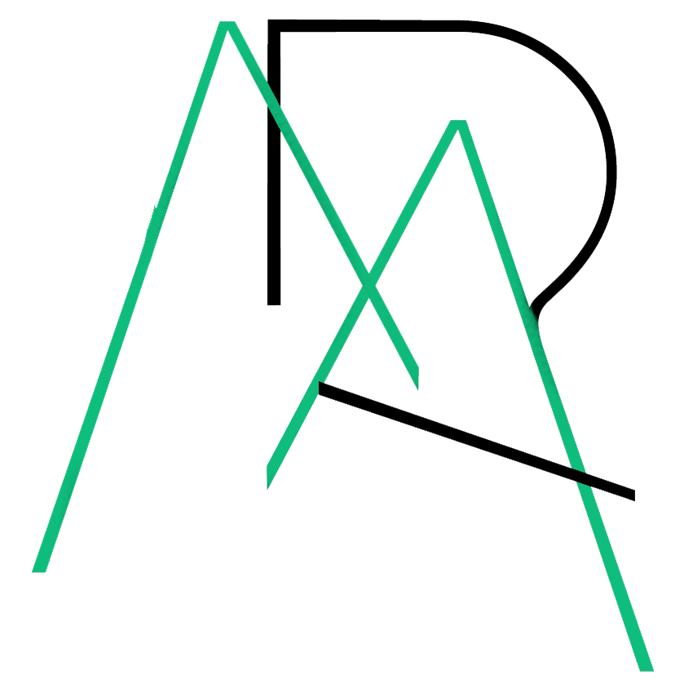 | MUDJIMBA  Residents’ Association Inc.  GENERAL MEETING AGENDA  1 December 2020  Mudjimba Community Hall, 41 Cottonwood St

Commencement 7:00pm
- Welcome and Acknowledgment of Country by Chair, Martin Peelgrane

- Apologies

- Confirmation of Minutes of Previous General Meeting, 6 October 2020.

3.1 Matters arising from Minutes:
3.1.1 Cottonwood Street Footpath
3.1.2 Queries to Cr O’Pray re proponent commitments from the SCAEP EIS
3.1.3 Mudjimba Beach Holiday Park expansion issues – caravans double parking and failure of council to provide a designated off-street or suitably signed short term waiting area
3.1.4 No caravan sign at corner of Coolibah and Sundew Streets

- Presentation by Mudjimba Surf Life Saving Club representative

- Council Update by Councillor Jason O’Pray
5.1 Queries from residents

- Airport Working Group Update

- . North Shore Flooding Forum Report by Darren Edwards

- OSCAR Report – see attached

- Twin Waters West Appeal Update – see attached

- Management Committee Update

- Sunshine Coast Australia Day Awards

- Other Business – from the Floor

- Next Meeting Date: 2 February 2021

- Close Meeting

ATTACHMENTS

Agenda Item 8 – OSCAR Report:
A number of ‘Have your Say’ opportunities exist via the Sunshine Coast Council website. All residents are encouraged to comment on matters that concern the Coast to ensure continued community consultation. Please visit the OSCAR website for details of these and other issues across the Sunshine Coast.

Agenda Item 9 – Twin Waters West Appeal update:
The ‘without prejudice’ conference is now to be held in Brisbane on 8 December 2020.

